|  |  |
| --- | --- |
| Name (Sap Id): | Kalpita Shankhdhar (60004210164)  Akshata Sunil Dharmadhikari (60004220125)  Prerna Sunil Jadhav (60004220127) |
| Class: | T. Y. B. Tech (Computer Engineering) |
| Course: | Software Engineering Laboratory |
| Course Code: | DJ19CEL601 |
| Experiment No.: | 09 |

**GIT:**

Git is a distributed revision control and source code management system with an emphasis

on speed. Git was initially designed and developed by Linus Torvalds for Linux kernel

development. Git is a free software distributed under the terms of the GNU General Public

License version 2.

Git Life Cycle

General workflow is as follows −

* Clone the Git repository as a working copy.
* Modify the working copy by adding/editing files.
* If necessary, update the working copy by taking other developer's changes.
* Review the changes before commit.
* Commit changes. If everything is fine, then push the changes to the repository.
* 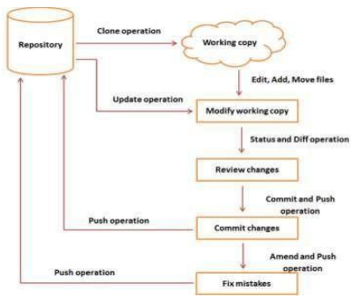After committing, if something is wrong, then correct the last commit and push the changes to the repository.

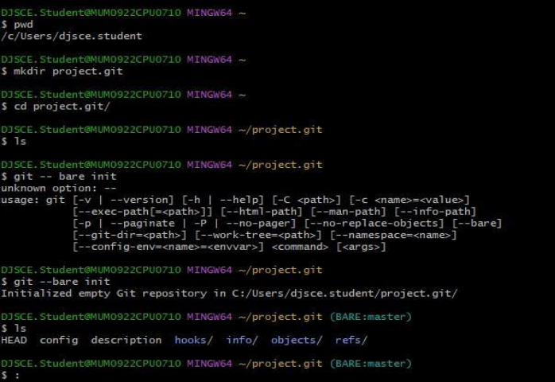Creating Git Repository:

Generate Public-Private RSA Key Pair:

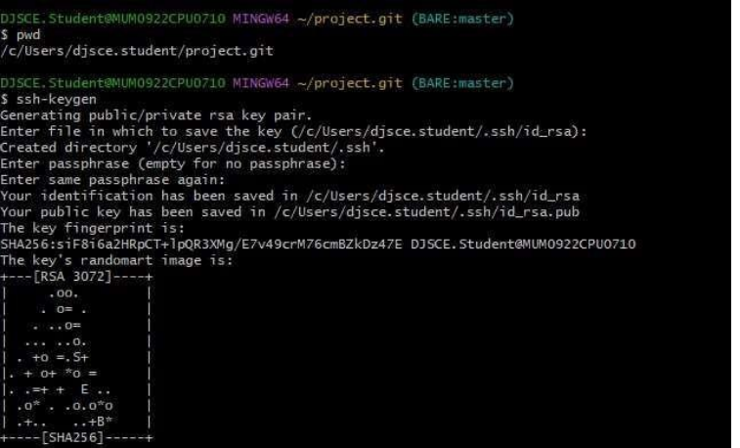

Adding keys to authorized keys:

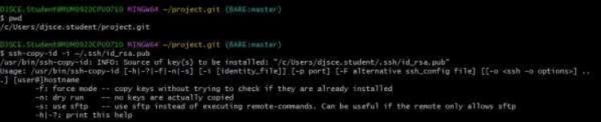

Push changes to the repository and Checking log message by executing the git log command:

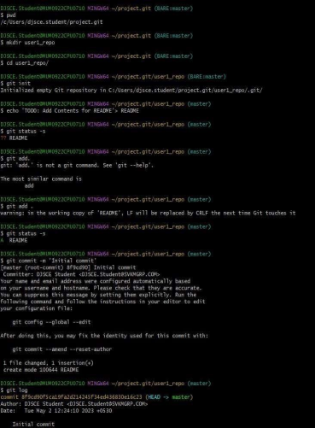

Commit changes:

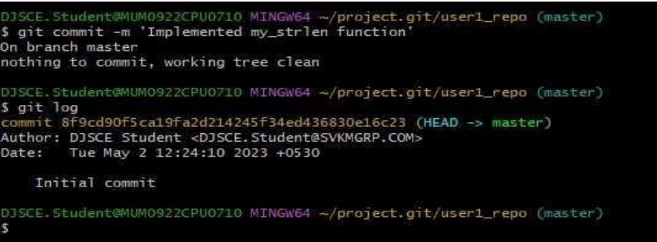

**CONCLUSION**:

Git is a version control system that can keep several versions on a local workstation or integrate

with a remote file management system. To perform commands, we used Git bash cmd and

saved the local files to the GitHub files management server. We also saw the git log command,

which stores the git activity log.